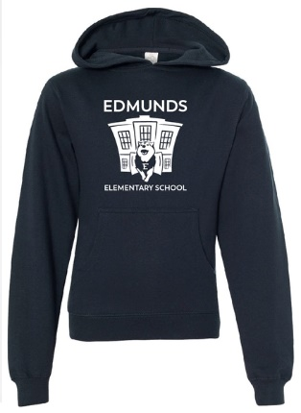
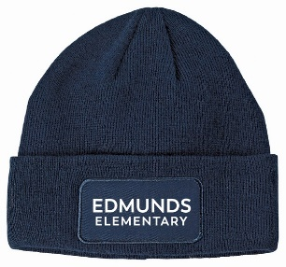
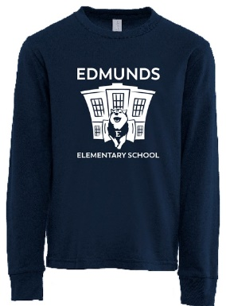
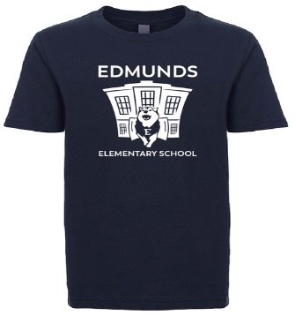
EDMUNDS ELEMENTARY SCHOOL MERCHANDISE
Just in time for our cold Vermont winter and the holidays!
Student Name: ___________________________________Grade: ________Teacher: _______________
Please check off item below and indicate size and quantity.
YOUTH SIZES: X-SMALL (4/5) SMALL (6/7) MEDIUM (8) LARGE (10/12) X-LARGE (14/16)
- Navy T-Shirt $14 XS S M L XL Qty: _______

- Navy Long Sleeve $20 XS S M L XL Qty: _______
60/40 cotton/poly blend

- Navy Hooded Sweatshirt $32 S M L XL Qty: _______
80/20 cotton/poly blend

- Cuffed Beanie $16 one size Qty: _______
acrylic
ADULT APPAREL
- Navy T-shirt--$17 XS S M L XL 2XL 3XL Qty:___

- Navy Long Sleeve--$25 XS S M L XL 2XL 3XL Qty:___
60/40 cotton/poly blend

- Navy Hooded sweatshirt--$35 S M L XL 2XL 3XL Qty:___
80/20 cotton/poly blend
2XL--$38 and 3XL--$40

- Cuffed Beanie--$16 one size Qty:___

- I would like to donate to a t-shirt fund for fellow EES students. $__________

Total Amount Enclosed: ___________________________ Please circle CHECK or CASH
Checks made payable to EES PTO. Please send order form back to your child’s teacher by Wednesday November 29th!!! Or…
…Visit the EES On-line Merch Store!
https://amalgamated-culture-works.printavo.com/merch/edmunds-elementary-school-merch-store/
Hosted by our local vendor, Amalgamated Culture Works!
Through DECEMBER 1st, you can choose to pay on-line by credit card.
For an additional $8, Amalgamated will print your last name on your swag! Name printing is only available in the on-line store.
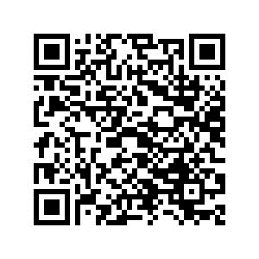

All merchandise to be delivered to the Edmunds front office on Friday December 15th
Merchandise will be available for pick up the week of December 18-22nd.

Adult Apparel Size Guide:
https://www.nextlevelapparel.com/media/pdf/2018-NLSizeGuide.pdf

